Question 1
Not yet answered
Marked out of 1.00
Flag question

Question text
All of the following are assumed to be constant when the supply curve for a product is drawn, except the:
Select one:
A. Number of producers
B. Price of the product
C. State of technology
D. Price of inputs used to make the product

Question 2
Not yet answered
Marked out of 1.00
Flag question

Question text
Suppose that a more efficient way to produce a good is discovered, thus lowering production costs for the good. This will cause a(n):
Select one:
A. Decrease in quantity supplied
B. Increase in quantity supplied
C. Decrease in supply
D. Increase in supply

Question 3
Not yet answered
Marked out of 1.00
Flag question

Question text
Which of the following will not cause the supply curve to shift?
Select one:
A. A change in the costs of resources needed to produce the good
B. A technological change in the production of the good
C. A change in the price of the good
D. A change in the prices of other goods that producers could be producing

Question 4
Not yet answered
Marked out of 1.00
Flag question

Question text
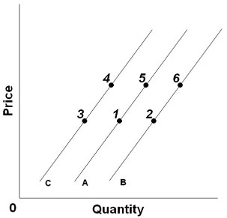
Refer to the above graph. An increase in price, other factors constant, would cause a change from:
Select one:
A. Point 3 to point 4
B. Point 5 to point 1
C. Point 4 to point 5
D. Point 1 to point 6

Question 5
Not yet answered
Marked out of 1.00
Flag question

Question text
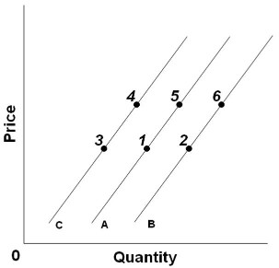
Refer to the above graph. A decrease in supply would best be reflected by a change from:
Select one:
A. Point 3 to point 6
B. Point 5 to point 1
C. Point 5 to point 2
D. Point 2 to point 1

Question 6
Not yet answered
Marked out of 1.00
Flag question

Question text
In competitive markets, a surplus or shortage will:
Select one:
A. Never exist because the markets are always at equilibrium
B. Cause shifts in the demand and supply curves that tend to eliminate the surplus or shortage
C. Cause changes in the quantities demanded and supplied that tend to eliminate the surplus or shortage
D. Cause changes in the quantities demanded and supplied that tend to intensify the surplus or shortage

Question 7
Not yet answered
Marked out of 1.00
Flag question

Question text
A decrease in supply, holding demand constant, will cause:
Select one:
A. Lower prices and a larger quantity sold
B. Higher prices and a smaller quantity sold
C. Lower prices and a smaller quantity sold
D. Higher prices and a larger quantity sold

Question 8
Not yet answered
Marked out of 1.00
Flag question

Question text
A decrease in demand, holding supply constant, will cause:
Select one:
A. Lower prices and a smaller quantity sold
B. Lower prices and a larger quantity sold
C. Higher prices and a larger quantity sold
D. Higher prices and a smaller quantity sold

Question 9
Not yet answered
Marked out of 1.00
Flag question

Question text
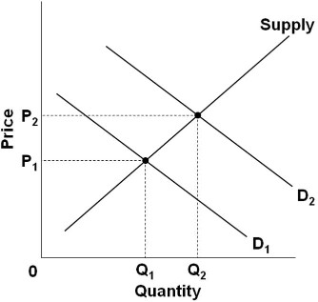
Refer to the above graph showing the market for a product. Which of the following would best explain why the shift in demand from D₁ to D₂ would cause price to rise from P₁ to P₂?
Select one:
A. Because after the shift in the demand, there would be a surplus at price P₁
B. Because after the shift in the demand, there would be a surplus at price P₂
C. Because after the shift in the demand, there would be a shortage at price P₁
D. Because after the shift in the demand, there would be a shortage at price P₂

Question 10
Not yet answered
Marked out of 1.00
Flag question

Question text
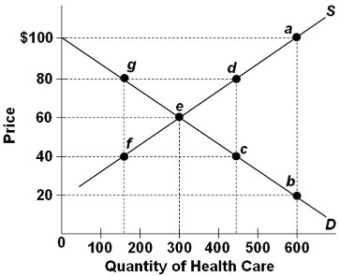
Refer to the above graph of a hypothetical market for health care. If there was not health insurance, the equilibrium price and quantity of health care would be:
Select one:
A. $60 and 300 units
B. $20 and 600 units
C. $80 and 450 units
D. $40 and 450 units

Question 11
Not yet answered
Marked out of 1.00
Flag question

Question text
When economists say that the demand for a product has decreased, they mean that:
Select one:
A. The product has become more expensive and thus consumers are buying less of it
B. The demand curve has shifted to the right
C. The product has become particularly scarce for some reason
D. Consumers are now willing and able to buy less of this product at each possible price

Question 12
Not yet answered
Marked out of 1.00
Flag question

Question text
An increase in the price of product B leads to an increase in the demand for product C. This indicates that products B and C are:
Select one:
A. Substitute goods
B. Normal goods
C. Complementary goods
D. Inferior goods

Question 13
Not yet answered
Marked out of 1.00
Flag question

Question text
When economists speak of "demand" in a particular market, they refer to:
Select one:
A. How much of an item buyers want to buy at a given price
B. The whole demand curve or schedule
C. One point on the demand curve
D. One price-quantity combination on the demand schedule

Question 14
Not yet answered
Marked out of 1.00
Flag question

Question text
The term "other things equal" means that:
Select one:
A. a number of relevant variables are assumed to be constant.
B. when variable X increases so does related variable Y.
C. all other goods are distributed equally.
D. the associated statement is normative.

Question 15
Not yet answered
Marked out of 1.00
Flag question

Question text
If X is a normal good, a rise in money income will:
Select one:
A. shift the demand curve for X to the right.
B. increase the quantity demanded.
C. shift the demand curve for X to the left.
D. decrease the quantity demanded.

Question 16
Not yet answered
Marked out of 1.00
Flag question

Question text
The price elasticity of demand is a measure of the:
Select one:
A. Responsiveness of buyers of a good to changes in its price
B. Effect of changes in demand on the price
C. Relationship between price and profitability
D. Sensitivity of a good's price to changes in demand

Question 17
Not yet answered
Marked out of 1.00
Flag question

Question text
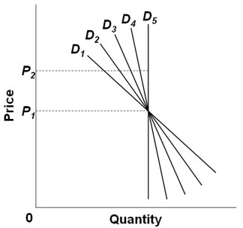
Refer to the graph above. Which demand curve is relatively most elastic between P₁ and P₂?
Select one:
A. D₁
B. D₂
C. D₃
D. D₄

Question 18
Not yet answered
Marked out of 1.00
Flag question

Question text
Suppose you are given the following data on demand for a product. The price elasticity of demand when price decreases from $9 to $8 is:
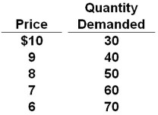
Select one:
A. -2.25
B. -0.63
C. -0.44
D. -1.16

Question 19
Not yet answered
Marked out of 1.00
Flag question

Question text
Total revenue falls as the price of a good is raised, if the demand for the good is:
Select one:
A. Perfectly elastic
B. Unitary elastic
C. Inelastic
D. Elastic

Question 20
Not yet answered
Marked out of 1.00
Flag question

Question text
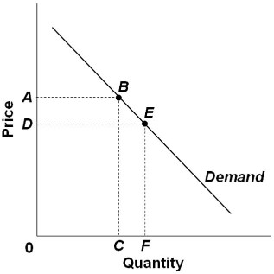
Consider the demand curve above. If the price is D, then the total revenues of sellers would be the rectangle area outlined by the letters:
Select one:
A. 0ABC
B. 0DEF
C. CBEF
D. DABE

Question 21
Not yet answered
Marked out of 1.00
Flag question

Question text
When the price of a product is increased 10 percent, the quantity demanded decreases 15 percent. The price-elasticity of demand coefficient for this product is:
Select one:
A. -0.67
B. -67
C. -1.5
D. -0.15

Question 22
Not yet answered
Marked out of 1.00
Flag question

Question text
In interpreting the Ed value as either elastic or inelastic, we look at the:
Select one:
A. Percent change in quantity
B. Percent change in price
C. Absolute value of the Ed coefficient
D. Ed coefficient with its negative sign

Question 23
Not yet answered
Marked out of 1.00
Flag question

Question text
Which is not characteristic of a product with relatively inelastic demand?
Select one:
A. Consumers have had only a short time period to adjust to changes in price
B. Buyers spend a small percentage of their total income on the product
C. There are a large number of good substitutes for the good
D. The good is regarded by consumers as a necessity

Question 24
Not yet answered
Marked out of 1.00
Flag question

Question text
Other things equal, and given that the elasticity of demand for health care is -0.2, a 10 percent increase in the price of health care in the United States will reduce the quantity of health care demanded by about:
Select one:
A. 5 percent.
B. 20 percent.
C. 1 percent.
D. 2 percent.

Question 25
Not yet answered
Marked out of 1.00
Flag question

Question text
The basic formula for the price elasticity of demand coefficient is:
Select one:
A. absolute decline in price/absolute increase in quantity demanded.
B. absolute decline in quantity demanded/absolute increase in price.
C. percentage change in quantity demanded/percentage change in price.
D. percentage change in price/percentage change in quantity demanded.

Question 26
Not yet answered
Marked out of 1.00
Flag question

Question text
The more time consumers have to adjust to a change in price:
Select one:
A. the smaller will be the price elasticity of demand.
B. the more likely the product is a normal good.
C. the more likely the product is an inferior good.
D. the greater will be the price elasticity of demand.

Question 27
Not yet answered
Marked out of 1.00
Flag question

Question text
Use the following demand and supply functions to calculate the equilibrium price.
Demand:Qd=50−4PQd=50−4P
Supply: Qs=20+2PQs=20+2P
The equilibrium price is:
Select one:
a. 30
b. 15
c. 5
d. 35

Question 28
Not yet answered
Marked out of 1.00
Flag question

Question text
Use the following demand and supply functions to calculate the equilibrium quantity.
Demand: Qd=50−4PQd=50−4P
Supply: Qs=20+2PQs=20+2P
The equilibrium quantity is:
Select one:
a. 41
b. 15
c. 52
d. 30

Question 29
Not yet answered
Marked out of 1.00
Flag question

Question text
Consider a market for output physical therapy services that is initially in equilibrium. Which of the following is mostly likely to occur if hospitals began providing more physical therapy before discharge?
Select one:
a. The supply curve for outpatient physical therapy would shift in.
b. The demand curve for outpatient physical therapy would shift in.
c. The supply curve for outpatient physical therapy would shift out.
d. The demand curve for outpatient physical therapy would shift out.

Question 30
Not yet answered
Marked out of 1.00
Flag question

Question text
The percentage change in the quantity demanded associated with a 1 percent change in the price of a related product is the

Select one:
a. cross-price elasticity.
b. income elasticity.
c. price elasticity.
d. All of the above.

Question 31
Not yet answered
Marked out of 1.00
Flag question

Question text
The demand for each individual firm’s products is usually
Select one:
a. inelastic because other firm’s products in the market are good substitutes.
b. inelastic because other firm’s products are poor substitutes.
c. elastic because other firm’s products in the market are good substitutes.
d. elastic because other firm’s products in the market are poor substitutes.


